## Appendix 7: Leadership Matrix Questionnaire

Below is a list of statements about leadership behavior. Read each one carefully, then, using the following scale, decide the extent to which it actually applies to you. For best results, answer as truthfully as possible.

**never    sometimes     always**

**0      1      2      3      4      5**

1. **_______**I encourage my team to participate when it comes decision making time and I try to implement their ideas and suggestions.
2. _______ Nothing is more important than accomplishing a goal or task.
3. _______ I closely monitor the schedule to ensure a task or project will be completed in time.
4. _______ I enjoy coaching people on new tasks and procedures.
5. _______ The more challenging a task is, the more I enjoy it.
6. _______ I encourage my employees to be creative about their job.
7. _______ When seeing a complex task through to completion, I ensure that every detail is accounted for.
8. _______ I find it easy to carry out several complicated tasks at the same time.
9. _______ I enjoy reading articles, books, and journals about management, learning, leadership, and psychology; and then putting what I have read into action.
10. _______ When correcting mistakes, I do not worry about jeopardizing relationships.
11. _______ I manage my time very efficiently.
12. _______ I enjoy explaining the intricacies and details of a complex task or project to my employees.
13. _______ Breaking large projects into small manageable tasks is second nature to me.
14. _______ Nothing is more important than building a great team.
15. _______ I enjoy analyzing problems.
16. _______ I honor other people's boundaries.
17. _______ Counseling and coaching my employees to improve their performance is second nature to me.
18. _______ I enjoy reading articles, books, and trade journals about my profession; and then implementing the new procedures I have learned.

### Scoring Section

After completing the questionnaire, transfer your answers to the spaces below:

|  |  |
| --- | --- |
| **People**  **Question**  1.**______**  4**.______**  6**.______**  9**.______**  10**.______**  12**.______**  14**.______**  16**.______**  17**.______**  **TOTAL ________**  X 0.2 = **________**  (multiply the Total by 0.2 to get your final score) | **Task**  **Question**  2.**______**  3**.______**  5**.______**  7**.______**  8**.______**  11**.______**  13**.______**  15**.______**  18**.______**  **TOTAL ________**  X 0.2 ________  (multiply the Total by 0.2 to get your final score) |

### Matrix Section

Plot your final scores on the graph below by drawing a horizontal line from the people score (vertical axis) to the right of the matrix and drawing a vertical line from the task score on the horizontal axis to the top of the matrix. The area of intersection is the leadership dimension in which you operate.

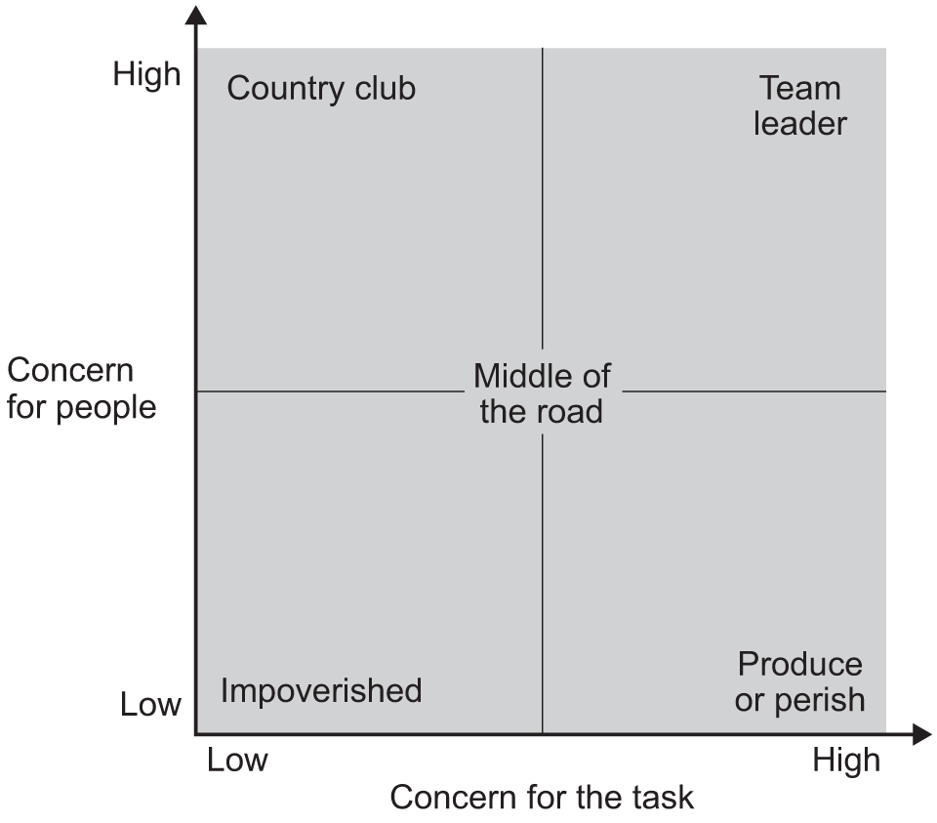

### Style Descriptions

**Team Leader (high task, high relationship) -**These leaders lead by positive example and endeavor to foster a team environment so that all team members can reach their highest potential, both as individual team members and as a group of people who use cooperation and collaboration. They encourage the team to reach goals as effectively as possible, while also working tirelessly to strengthen the bonds among the various members. They normally lead some of the most productive teams.

**Produce or Perish Leader (high task, low relationship)** - Leaders who get this rating are very much task oriented and are hard on their workers ([autocratic](http://www.nwlink.com/~donclark/leader/leadstl.html)). There is little or no allowance for cooperation or collaboration. Authoritarian leaders mostly display these characteristics: they are very strong on schedules; they expect people to do what they are told without question or debate; when something goes wrong they tend to focus on who is to blame rather than concentrate on exactly what went wrong and how to prevent it; they are intolerant of what they see as dissent (it may just be someone's creativity), thus it is difficult for their subordinates to contribute or develop.

**Country Club Leader (low task, high relationship)** - These leaders predominantly usereward power to maintain discipline and to encourage the team to accomplish its goals. Conversely, they are almost incapable of employing the more punitive, coercive and legitimate powers. This inability results from fear that using such powers could jeopardize relationships with the other team members.

**Impoverished Leader (low task, low relationship)**- These leaders use a “delegate and disappear” management style. Since they are not committed to either task accomplishment or maintenance, they essentially allow their team to do whatever they wish and prefer to detach themselves from the team process by allowing the team to suffer from a series of power struggles within the group.

Source: http://www.nwlink.com/~donclark/leader/matrix.html